**A new and novel way to recognize surgical instrument**

**By Artificial Inteligence**

|  |  |  |  |
| --- | --- | --- | --- |
| **Author** | **date** | **Note** | **email** |
| **Thomas.Lin** | **24/1/2016** | **Version 0.1** | **2589998363@qq.com** |

Traditionally,in order to track or identify the surgical instruments,we usually add label on it ,like datamatrix,RFID chip,plastic coating and so on. To install and maintain the label on the them,the instruments will be damaged more or less.

Here,i would like to intruduce a new and novel way to reconize the surgical instrument without add any foreign element on it.It will be done by the latest artifical intelegence technology-pattern recogniztion.

What we needs:

1. A handhold scanner with camera that can be connected to a computer.

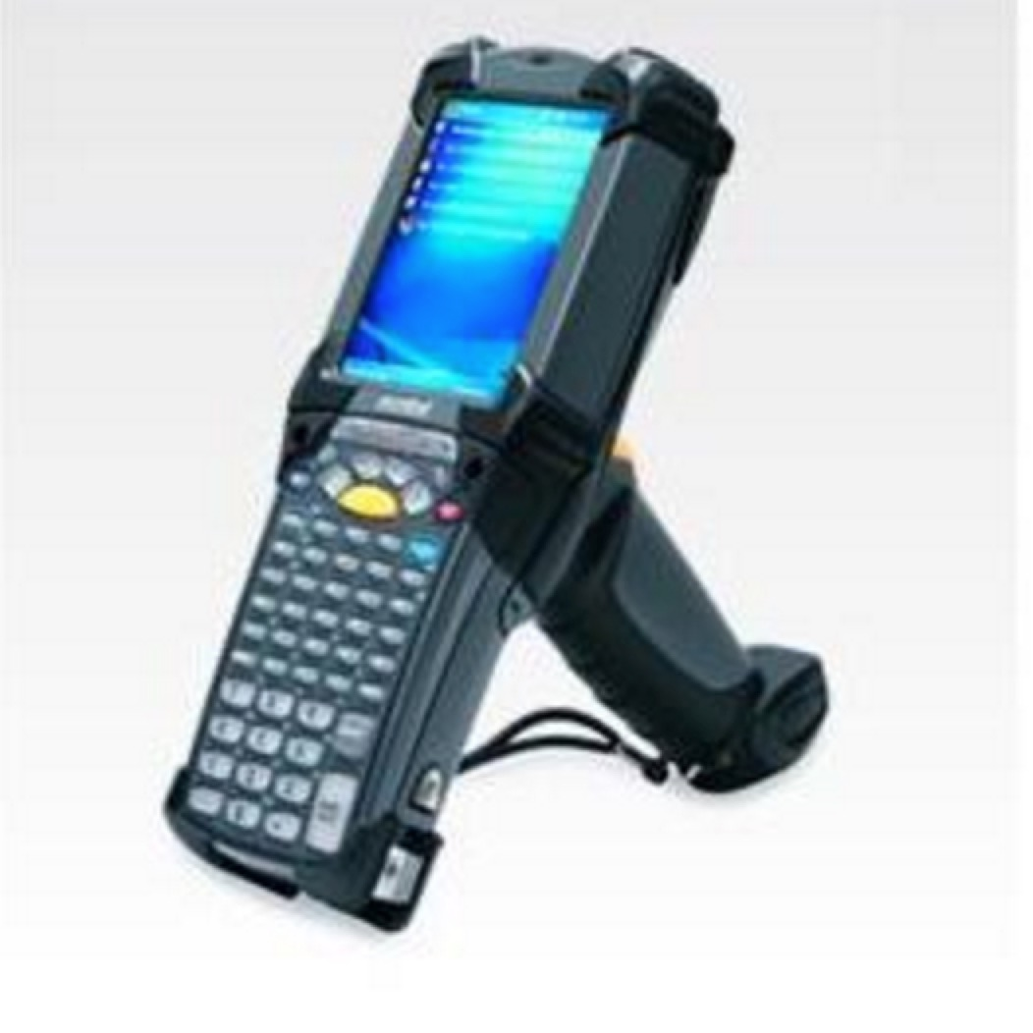

1. An automatic Number Plate Recognition program. e.g. Automatic License Plate Recognition,which have been proven and used all around the world.
2. A databasebase that stores the infomation of all kind of surgical instruments,e.g. Item no.,size,name and so on.
3. A program application that can be connected to the handheld scanner and automatic Number Plate Recognition program.

Steps:

1. Take a picture of surgical instrument,and upload it to the computer through the scanner

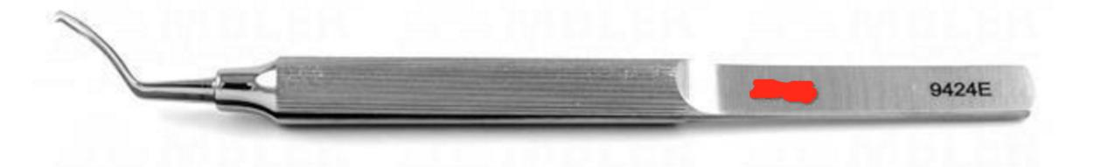

1. A automatic Number Plate Recognition program installed in the computer will get the picture and reconize the Item no. In the picture. And then send the item no to the program we made.
2. The program will search the database and get the result and send it back to the scanner.The screen of the scanner will show the detail info of the surgical instrument to the User

The workflow is like:

The scanner show the detail info of the surgical instruments

End

The program we made recieve the Item no. ,get the result from the database and send it back to the scanner

An automatic Number Plate Recognition program will recognize the item no.

Take a pic of the surgical instrumetns and upload it to the computer

Begin